Directions: Solve the systems of equations by graphing each equation.
$y=−2x+1$ $y=x−8$

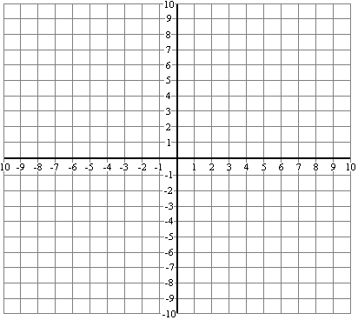
$y=x+2$ $y=2x+4$

$y=3−2x$ $y=3x+1$

Directions: Solve the system of equations by any method.

$y−3=x$ $4x−y=−2$ $2x+y=2$ $2x−2y=2$
$3x+y=\text{11}$ $−8x+y=3$ $4x−2y=−4$ $3x+y=−9$

$x+3y=\text{12}$ $−2x+4y=−4$ $−3x+5y=\text{12}$ $2x+3y=\text{12}$
$2x−3y=6$ $2x−2y=6$ $3x−5y=\text{12}$ $4x−3y=−\text{18}$

